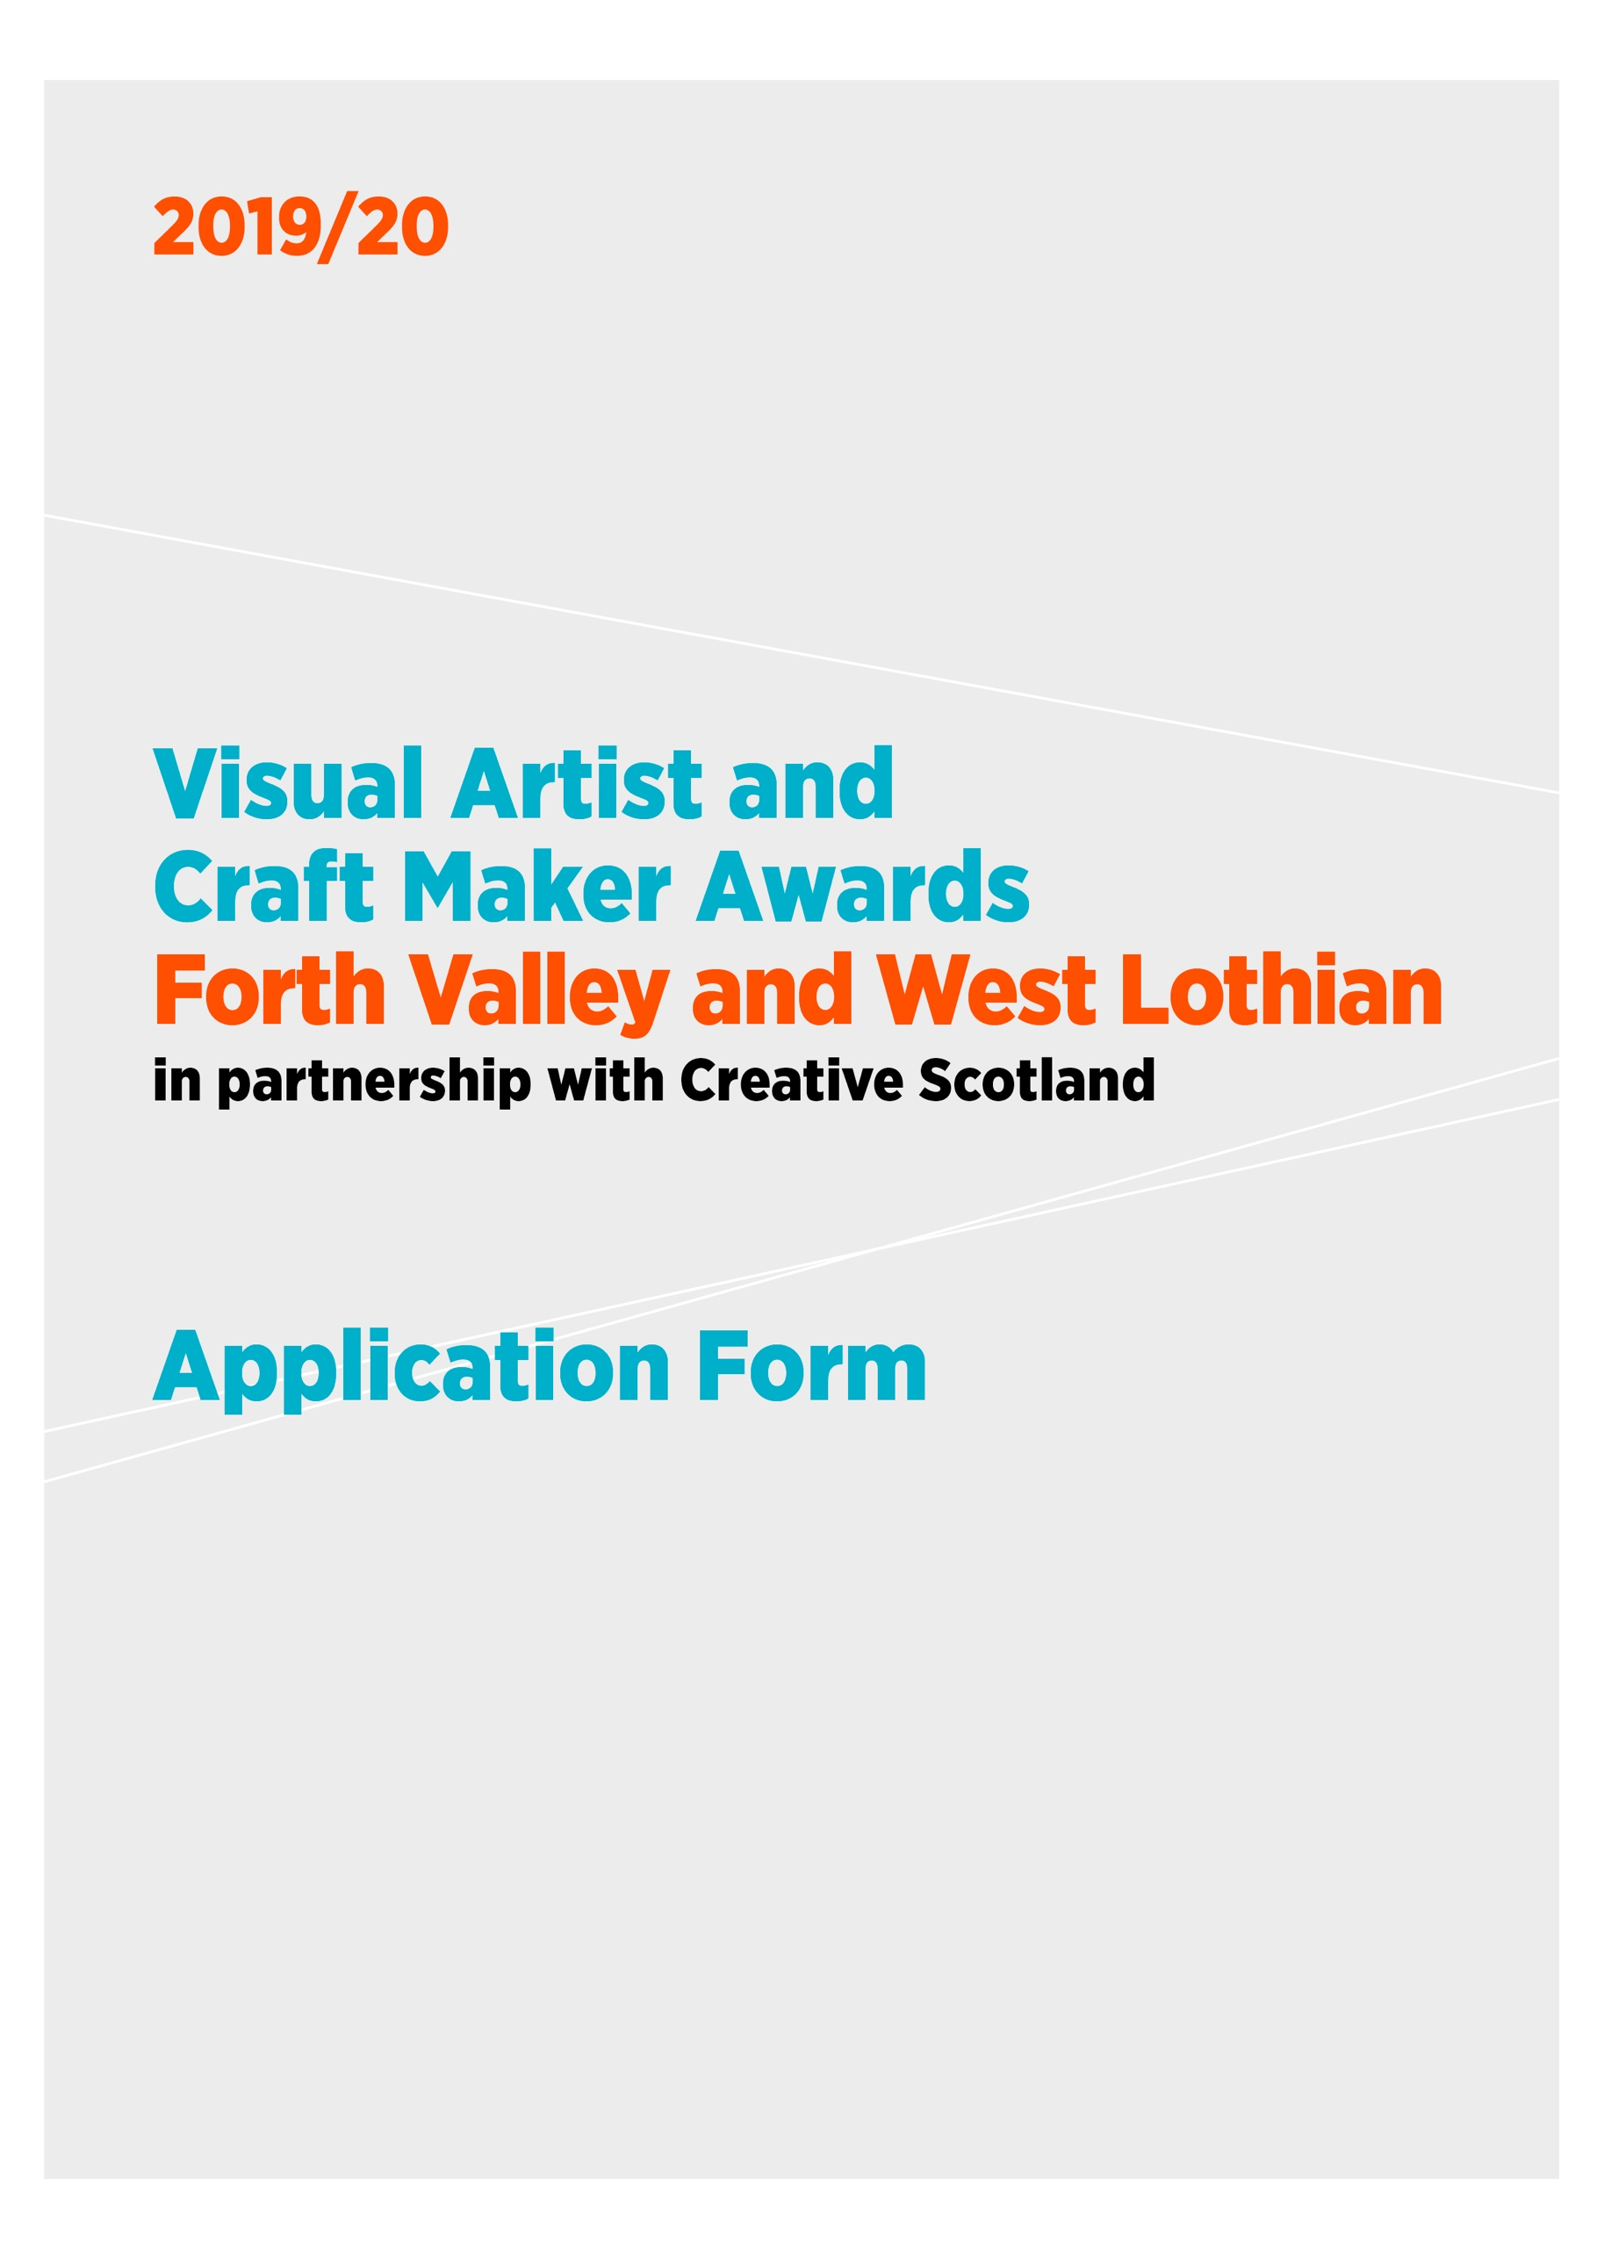

VACMA: FORTH VALLEY AND WEST LOTHIAN is funded through a partnership between Falkirk Community Trust, Stirling Council, West Lothian Council and Creative Scotland



**1 APPLICATION DETAILS**

Please ensure that you have read the Guidelines carefully before completing the form.

**Name:**

**Address:**

**Postcode:**

**Contact telephone number(s):**

**Email:**

**website:**

Start date:

Expected end date:

**Amount of funding requested (between £500-£1,500):**

**OR**

**I am applying for the New Graduate / Emerging Artist Bursary of £500 🞏**

|  |  |
| --- | --- |
| **Artform** tick one box only | |
| Visual Art |  |
| Craft |  |

**2 SUPPORTING INFORMATION**

* **Please submit a copy of your current artist CV** (this helps us to understand what you have achieved so far in your practice, your training and track record). You may also include your artist statement.
* If you are applying for support for the development of work for an exhibition or for a residency, please provide a letter of support from the gallery / organisation which explains what they will be providing
* Please submit up to 6 high quality images or up to 5 minutes of film/sound files
* **Please complete the Equalities Monitoring form**

**3 ABOUT YOU**

**Please tell us briefly about your practice.**

What do you do and why do you do it? Max 250 words

**What do you want funding for?** Max 500 words

**How will this develop your practice and what do you want to achieve in the long term?**

Max 250 words

**Is there any public element to the proposal?**  e.g. an event, performance or exhibition. If yes, tell us more about it. Max 200 words

**Please give an outline and timetable (including dates) of the key stages and any preparation work you have done**.

**4 PREVIOUS APPLICATIONS**

**Have you had a VACMA, or Creative Scotland award before? If so, when?**

*If you have, please tell us how that support helped your practice, and whether this is a continuation of that project.*

*Priority in awards may go to those who have* ***not*** *previously been successful in the scheme. Applications will not be considered from previously successful applicants who have not yet submitted their End of Project Report.*

**5** **PLACE**

**How long you have been resident in the area?**

*If you are not resident please say why you are applying to this scheme in this area.*

**6 BUDGET**

Please provide a budget breakdown for your project, detailing the grant requested, your own financial contribution and any other sources of funding. Please indicate if these are cash or in-kind contributions and ensure in-kind is accounted for in both income and expenditure. If the cost exceeds £1,500, please include other sources of income and funding, showing which have been confirmed at time of application.

|  |  |  |
| --- | --- | --- |
| **Expenditure - Breakdown of Estimated Project Costs** | | |
| **item** | **cost £** | **Cash or in-kind** |
|  |  |  |
|  |  |  |
|  |  |  |
|  |  |  |
|  |  |  |
|  |  |  |
|  |  |  |
| **Total Cost of Project** |  |  |

|  |  |  |
| --- | --- | --- |
| **Income – this figure should equal your expenditure above** | | |
|  | **£** | **Confirmed**  **Cash or in-kind** |
| **Grant request from Award Scheme:** |  |  |
| **Own cash contribution:** |  |  |
| **Other sources of income (if applicable):** |  |  |
| **Total Estimated Income for Project:** |  |  |

The focus of this fund is to support new opportunities for creative development and the change this can bring to your practice. Whilst we recognise that artists/makers time is crucial to creating new work or undertaking professional development activities we are **not** able to support day to day living costs or replace other income.

For the purposes of this application any time contribution is viewed as in-kind contribution and part of your professional practice. However, we would like to better understand the nature of this contribution so please provide the following information:

|  |  |
| --- | --- |
| **Number of days you intend to spend on this project:** |  |

**7 ARTWORK SUBMISSION FORM**

Name:

Image format:

(jpeg on CD, DVD, USB, etc)

Please enter details of the artwork submitted in support of your application. We cannot accept original artwork. **Please read ‘How to Apply’ notes on the guidance form**.

We request that all supporting material is clearly labelled with your name and the title of works.

|  |  |  |  |  |
| --- | --- | --- | --- | --- |
|  | **Images/ Work Title** | **Date** | **Size** | **Medium and Description** |
| 1 |  |  |  |  |
| 2 |  |  |  |  |
| 3 |  |  |  |  |
| 4 |  |  |  |  |
| 5 |  |  |  |  |
| 6 |  |  |  |  |

Please note we cannot accept responsibility for damage to or loss of material submitted in support of applications, although we will exercise all possible care in handling this material.

We are committed to protecting the rights and privacy of individuals in accordance with the Data Protection Act 2018.

The Trust must comply with Data Protection Legislation.  
You can find out how we handle personal data at  [www.falkirkcommunitytrust.org/privacy-policy](https://mail.falkirk.gov.uk/owa/redir.aspx?REF=d8pHdAr5qrynSD-5YE5VowjNn1JuRsbfpJHe7jt8eQbBXkur5x_XCAFodHRwOi8vd3d3LmZhbGtpcmtjb21tdW5pdHl0cnVzdC5vcmcvcHJpdmFjeS1wb2xpY3k.)

**DECLARATION**

I (print full name) _____________________________________ hereby apply for financial assistance towards the cost of undertaking the project described in this application. To the best of my knowledge and belief, the information given is correct.

Signature:

Date:

**Completed application forms should be returned to:**

Dawn Nichol

Clerical Assistant

Falkirk Community Trust

Falkirk CommunityStadium

4 Stadium Way

Falkirk FK2 9EE

(01324)590900

dawn.nichol@falkirkcommunitytust.org